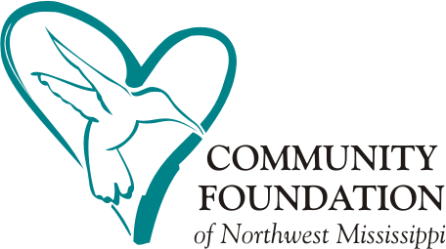GRANT FAQs

Q. Can I get money from The Community Foundation for personal needs?

No, the Community Foundation does not make grants or loans to individuals. For students, there are several scholarships available; funding for scholarships is sent directly to the educational institution on the student’s behalf.

Q. What types of grants are available?

CFNM focuses on programs that involve health and education, especially for youth and children. There are four pillars for granting: Endowment for the Future of Northwest Mississippi, Place-Based Education & Civic Entrepreneurship, Technology in Education, and Early Childhood Education. The CFNM Grants Committee will classify the category of the grant request for funding.

Q. How do I apply for a grant?

Visit <https://goapply2.akoyago.com/NWMISSIS> to apply for a competitive grant.

Q. What are the deadlines for grant applications?

The Annual Competitive Grant Application is scheduled to open on July 1st and closing on August 1st. Applications will not be accepted after the deadline, as to not hold up the process.

Q. Does my nonprofit need a 501(c)(3) designation from the IRS before I can apply for and receive grant funding?

Yes. Your organization must have a 501(c)(3) status designation or be an entity of government to apply for a grant and receive funding.

Q. We are an entity of the government (public educational institutions, departments of government, etc). Do we still need a 501(c)(3) designation?

No, the entities of government will not have 501(c)(3). It is suggested that you contact us for eligibility.

Q. Can anyone help me write a grant proposal?

We do not provide direct assistance with writing proposals. However, we can suggest that you contact the HUB for training resources.

Q. What happens if my budget changes or there is a shift in the program from what was originally proposed?

If there are changes to your application during consideration, or after you have been funded, you will need to contact the CFNM Grants Manager ([grants@cfnm.org)](mailto:grants@cfnm.org) on how to proceed. DO NOT ASSUME you are able to change the purpose of your project first without consultation.

Q .What happens after my application is funded?

An auto-generated email will be sent to the grant contact on the application with instructions to sign into the GOapply portal to accept the grant agreement. The grant agreement needs to be signed before funds can be released. If you do not accept this agreement timely, funds will not be released and may not be available. You have approximately one year to use funds. Dates will be included in the grant agreement. Any unused funds must be returned to CFNM. You may receive a site visit from CFNM within your grant period.

Q. Will I need to submit a report?

Yes, CFNM requires a final report. These reports consist of the program and fiscal results outlined in your grant request. Failure to submit a report may affect consideration of future requests. We encourage you to share honest results – what worked and what did not. This improves outcomes for future projects and a way for CFNM to share with others. You can find a final report online at [Competitive Grants –](https://cfnm.org/grants/competitive-grants/) [Community Foundation of NW Mississippi (cfnm.org).](https://cfnm.org/grants/competitive-grants/)

Q. Why didn't my project receive funding this time?

While there is no guarantee that CFNM will fund a specific grant request, it is committed to funding organizations that present opportunities for partnerships and that demonstrate an ability to leverage resources. If you do not receive funding, it is not necessarily a reflection of your program, generally, it is only indicating that the Community Foundation funds are limited. Remember: this is A COMPETITIVE grants process!

Q. How often can my organization apply?

The Foundation does not set a limit on the number of times an organization can apply for funding. Generally, we prefer that organizations use discretion and submit requests only for top-priority projects and programs.

Q. Who reviews my grant request?

Foundation staff reviews all incoming grant requests for the Competitive Grants cycle. A volunteer grants committee reviews and recommends to the CFNM Board of Directors grant requests for funding. The Foundation’s Board of Directors reviews and votes to approve the recommended grants funding.

Q. Can I meet with The Foundation before applying?

We encourage you to meet with us, so we have a good understanding of your grant request to submit to the Grants Committee. However, this does not guarantee funding.

Q. How much money should my organization request?

There is a wide range in the dollar amounts of grants awarded. The amount of funding awarded by CFNM has varies between $100.00 and $20,000.00 with the average being $5,000.00. Your project budget should reflect the total amount of funds needed.

Q. Are administrative/ shared expenses supported by competitive grants? Generally, no.

Q. What if I have other questions or need help?

Contact us at [grants@cfnm.org](mailto:grants@cfnm.org) or call our office at 662.449.5002.

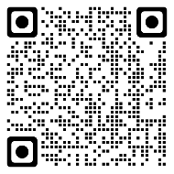

Scan the code above or go to https://cfnm.org/grants/competitive-grants/ to visit our Competitive Grants page for more information.